**Experimental Setup:**

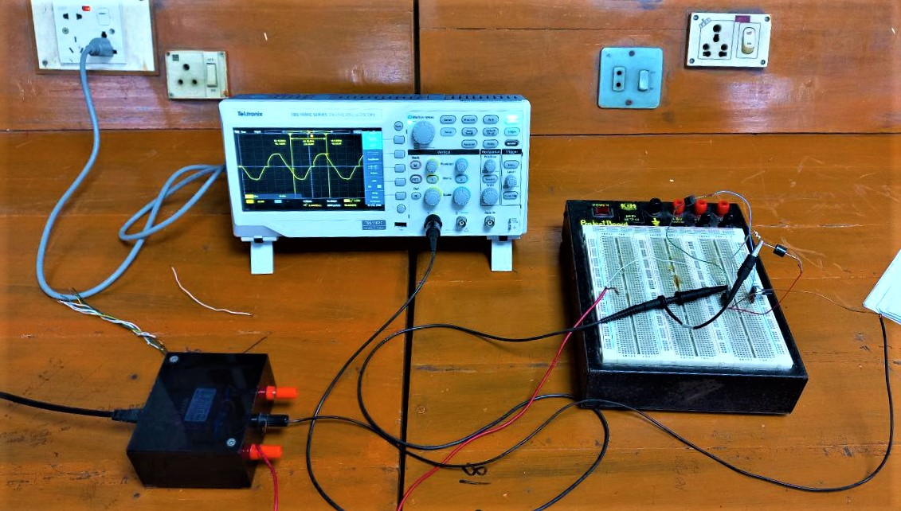

Fig.4.3: Apparatus Setup for the experiment of half Wave AC Voltage Controller

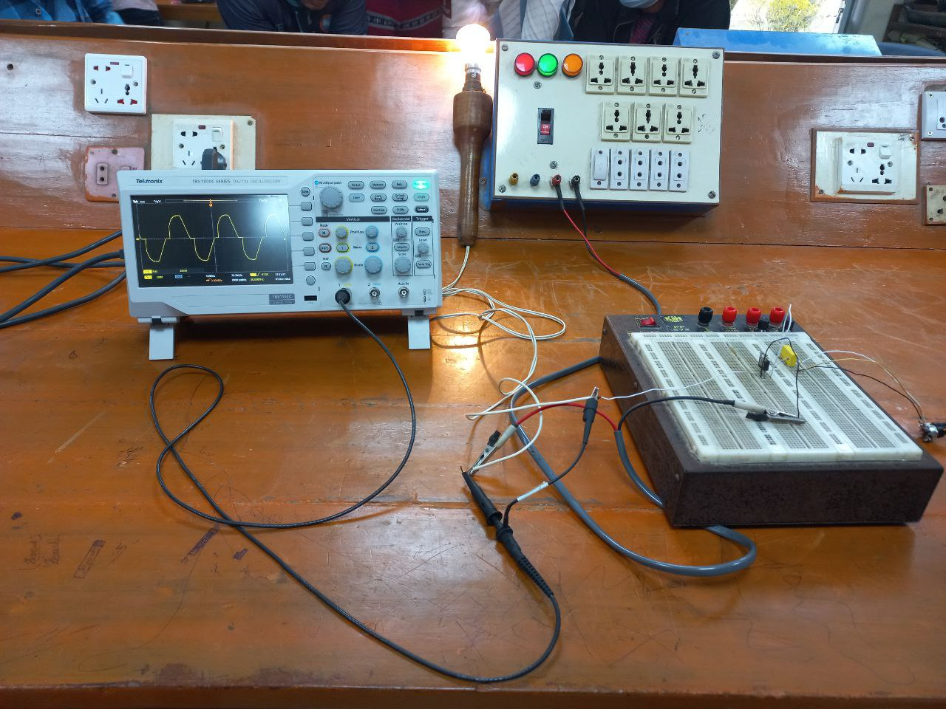

Fig.4.4: Apparatus Setup for the experiment of full Wave AC Voltage Controller

**Output Waveshapes:**

**Half Wave AC Voltage Controller**

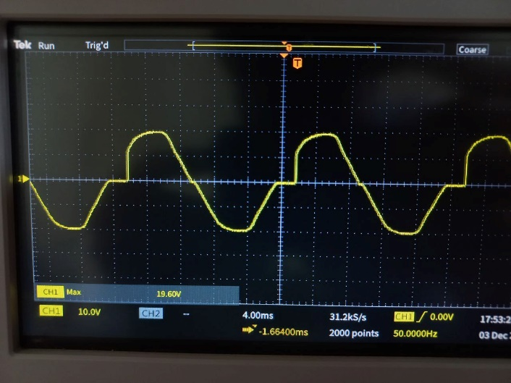

Fig.4.5: Output across resistor (low firing angle)

The firing angle in fig. 4.5 was low, while it was high in fig. 4.6. Because it is a half-wave ac voltage controller, it can only regulate the positive half of the signal. The rms value was higher for low firing angles because the signal was on most of the time. However, the rms value for high firing angle was lower than previously.

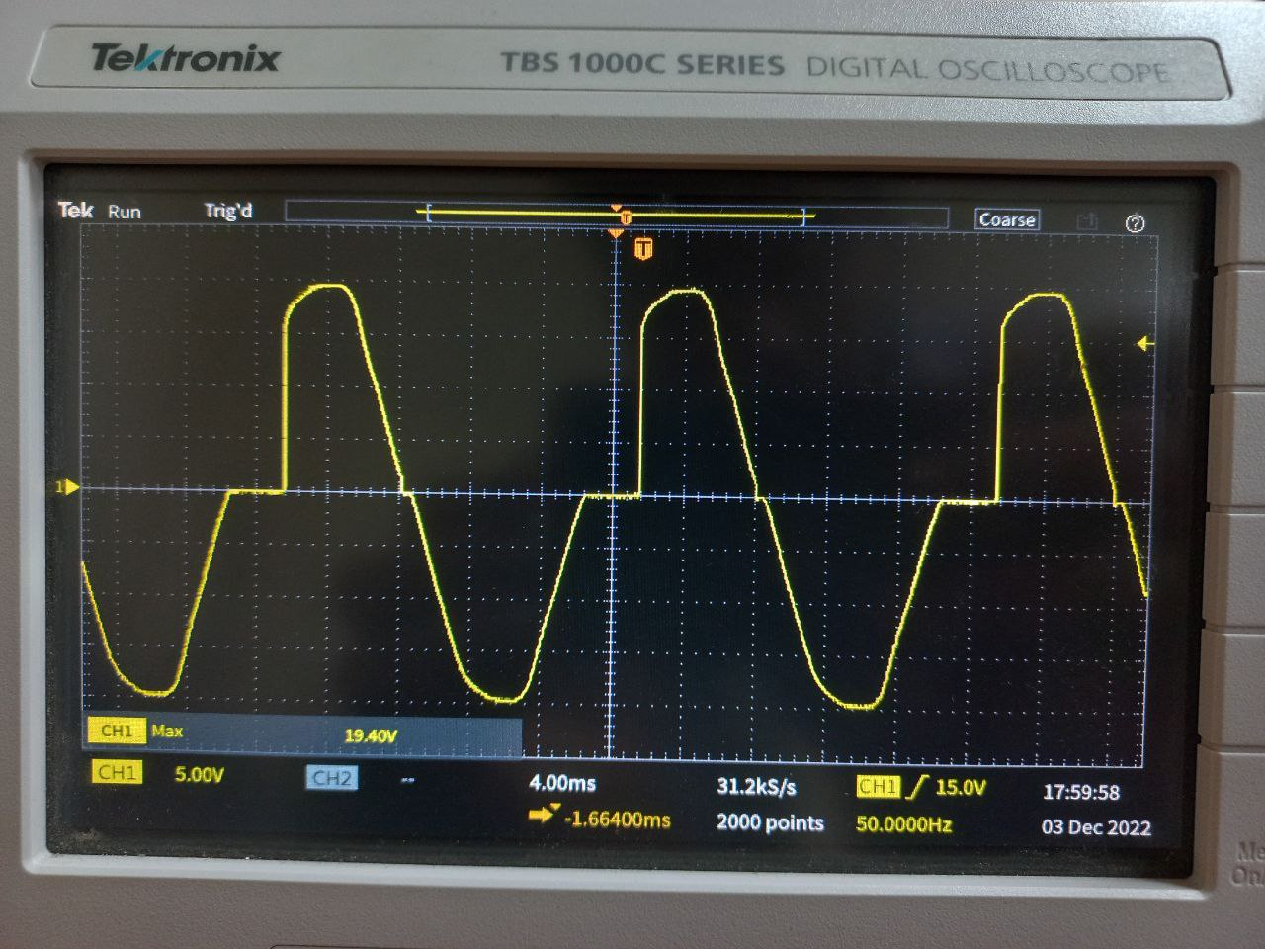

Fig.4.6: Output across resistor (high firing angle)

**Full Wave AC Voltage Controller**



Fig.4.7: Output across resistor (low firing angle)

In fig. 4.7, the firing angle was small and the signal's rms value was large. The firing angle was high in fig. 4.8, hence the rms value was smaller than before. Because it was a full wave ac voltage controller, it could control both halves of the signal. The firing angle was the same for both halves of the signal, and the gate pulse for the negative half cycle was reversed.

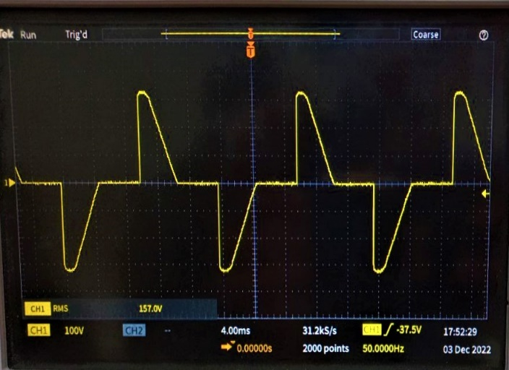

Fig.4.8: Output across resistor (high firing angle)